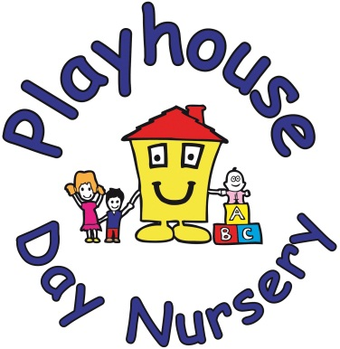

287 Hatherley Road, Up Hatherley
Cheltenham, Glos, GL51 6HT
01242 253212, playhouse12345@aol.com

Fee Policy – Funded hours and charges

At Playhouse Day Nursery we are committed to delivering high-quality, affordable and accessible childcare services in line with the statutory guidance on early education and childcare entitlements. This policy outlines how we offer the government funded early education hours, additional charges and our approach to transparency in invoicing, in accordance with the latest Early Years Foundation Stage (EYFS) statutory guidance and the Early Education and Childcare entitlements guidance, effective from January 2026.

Funded Early Education Entitlement
We offer government funded childcare places as part of the 15 and 30hr entitlement scheme for eligible 9 months, two, three and four year old children. These funded hours:
- Are available free of charge to parents
- Are offered during agreed sessions, in line with the EYFS requirements

Additional Charges
While the government funding covers the cost of delivering high quality early education, it does not cover:
- Meals (Snacks, Cooked lunch and pudding and Hot/cold tea and pudding)
- Non-food consumables (Wipes, nappy cream, Calpol, etc.)
- Activities and extras (Mothers and Father’s day events, Graduation party, music and movement, cooking activities, trips)

Parent Contribution
We ask parents to voluntarily contribute towards these additional costs so that we can continue to deliver high quality childcare. We take pride in offering home cooked nutritious healthy meals cooked onsite during the day. We follow the EYFS nutritional guidance to make sure all children are catered for their age and stage of development. Our food is prepared safely by our two cooks who have extensive training in food safety. We offer morning snacks, hot lunches and afternoon teas. All of our staff are paediatric first aid trained (above the minimum requirements) this ensures your child/ren are kept safe at all times.

Transparency and Invoicing
To ensure transparency and compliance with the statutory guidance, our invoices will clearly itemise the following:
- Funded entitlement hours received
- Additional private paid hours/sessions where applicable
- A breakdown of our additional charges during the funded hours
Charging for private hours
Parents may choose to book additional private childcare hours/sessions beyond their funded entitlement hours. These additional hours/sessions:
- Are subject to our standard hourly/sessions rates
- Must not be a requirement for accessing a funded place.

Flexibility of hours
- Parents will receive clear information on how many funded hours they are entitled to per week
- There will be no artificial breaks in the funded entitlement hours that prevent parents from using their full entitlement in a way that supports their work commitments
- Patterns of provision will depend on availability within the nursery.

Alignment with EYFS 2025 changes
This policy reflects the latest EYFS updates effective from September 2025, ensuring that our setting remains compliant with the new requirements, including:
- Clearer invoicing and a breakdown of charges by January 2026
- Ensuring fair access to funded places

This policy was adopted on | Signed on behalf of the nursery | Date for review
01st January 2026 |  | January 2027

