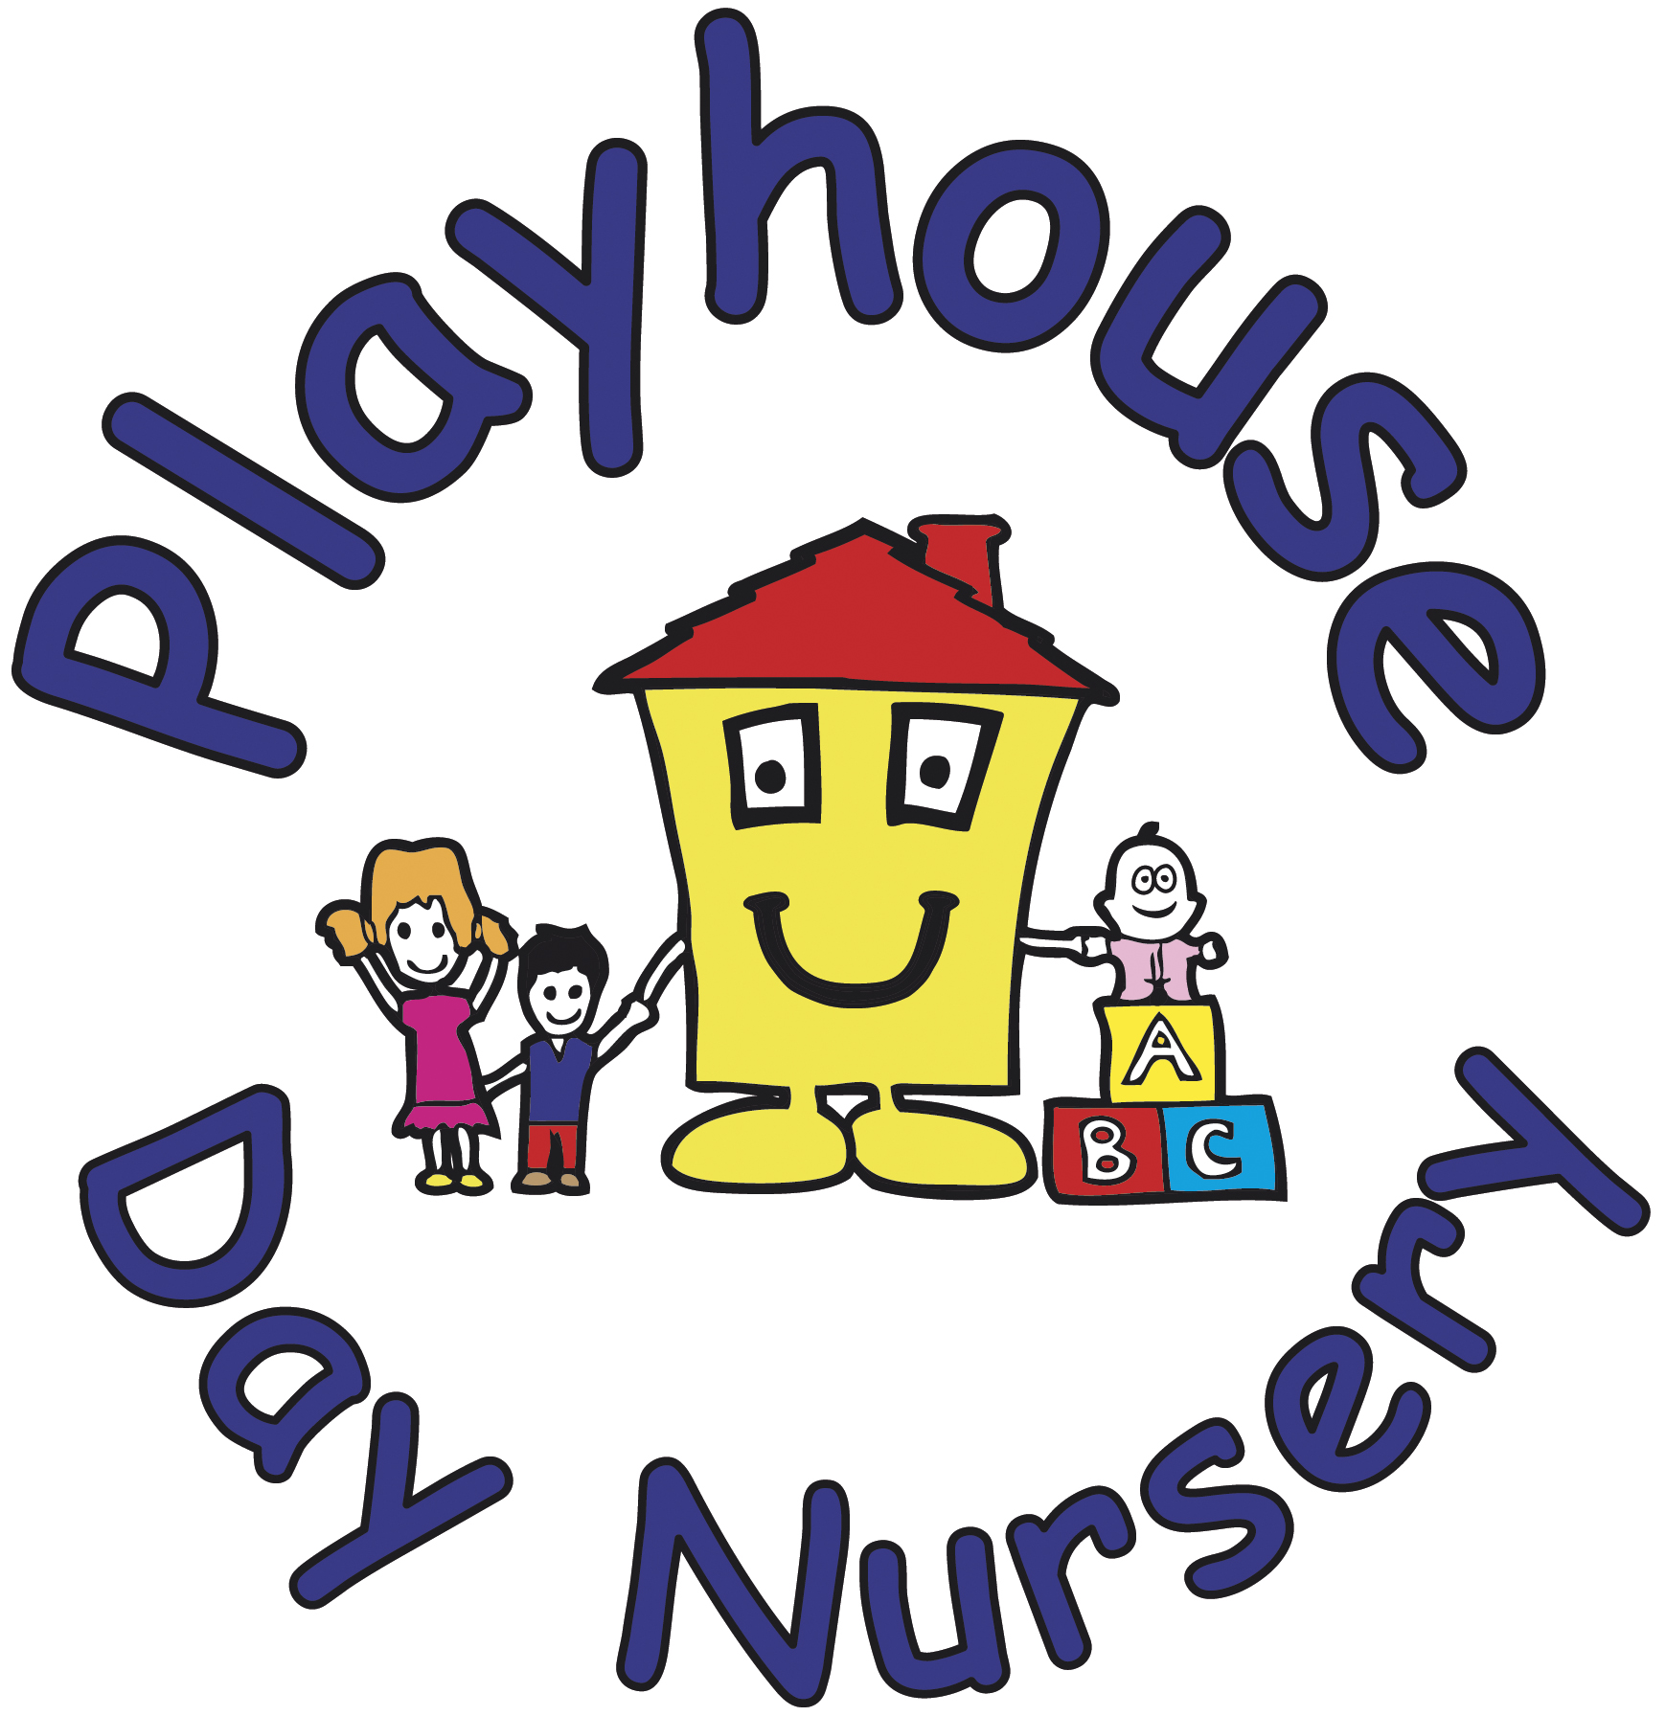
287 Hatherley Road, Up Hatherley
Cheltenham, Glos, GL51 6HT
01242 253212, playhouse12345@aol.com

Funding Information for 9mths, 2, 3 and 4 year olds
30 hours childcare – For children aged 9 months to 4 years
Eligible working families can apply for 30 hours of childcare to use from the term after their child turns 9 months until they reach school age.
The following table shows when a child is eligible to receive funding:
A child turning 9mths, 2yrs and 3yrs between: | Will be eligible for a funded place from:
1st January and 31st March | The start of the Summer term following them turning 9mths and their 2nd or 3rd birthday or until statutory school age
1st April and 31st August | The start of the Autumn term following them turning 9mths and their 2nd or 3rd birthday or until statutory school age
1st September and 31st December | The start of the Spring term following them turning 9mths and their 2nd or 3rd birthday or until statutory school age

The deadline dates to apply for your funding codes are:
- 31st March to access the 30 hours childcare for eligible working families in the Summer term
- 31st August to access the 30 hours childcare for eligible working families in the Autumn term
- 31st December to access the 30 hours childcare for eligible working families in the Spring term
To check eligibility and to take part in this scheme please visit https://beststartinlife.gov.uk and inform us of your code by the eligibility date so that we can verify it for you.

Age 9-23 months | September 2025 | Age 2 years | September 2025 | Age 3-4 years | September 2025
Working families | 30 hours | Working families | 30 hours | Working families | 30 hours
 |  | Families receiving additional support | 15 hours | All families | 15 hours

15 hours entitlement
- 15 hours funding for 38 weeks a year
- A total of 570 hours per year, that you can use flexibly with one or more childcare provider.
- If you are not eligible for the working parent offer you will still receive the 15 hour funding for all 3&4 year olds from the term after your child turns 3 until they start school.
- If you or your child receive additional forms of support, you maybe eligible for 15 hours funding for 2 year olds under the 2 year old funding scheme, you can apply for this through Gloucestershire County council website.
30 hours entitlement
- For working families
- 30 hours funding for 38 weeks a year
- A total of 1140 hours per year, that you can use flexibly with one or more childcare provider.
To be eligible for the 30 hours funded childcare:
- You, and any partner, must be working and earning the equivalent of 16 hours per week at the National Minimum/Living wage.
- If you, or your partner, are on maternity, paternity or adoption leave, or your unable to work because you are disabled or have caring responsibilities, you could still be eligible.
- You cannot receive the 30 hours funded childcare if you, or your partner, expect to earn £100,000 or more per year.

How do I apply?
You need to meet the eligibility criteria before you can claim the 30 hours funded childcare.
You need to apply to https://beststartinlife.gov.uk
You’ll need to make sure you have the following information to hand before starting the application:
- Your national insurance number (or unique taxpayer reference if you are self-employed)
- The date you started or are due to start work
- Details of any government support or benefits you receive
- The UK birth certificate reference number (if you have one) for your child.
You may find out if you’re eligible straight away, but it can take up to 7 days.
Once your application has been approved, you’ll get a code for your funded childcare to give to your childcare provider.
To keep your funded childcare place you need to reconfirm your code every 3 months.
Eligible parents are also able to access Tax-Free Childcare through the same application system. However, you don't need to apply for Tax-Free Childcare to be eligible to apply for the 30 hours funded childcare.
This is how Playhouse will be offering the 15/30 hours funded childcare:
At Playhouse we do fully support the government in helping families with childcare costs, however as the funding comes with a shortfall and does not cover our nursery fees, we have no choice but to charge for meals and snacks, non-food consumables and activities and extras. As the government funding only covers the education element.
We will only be offering term time only places for our pre-school children, these are our 3-4 year olds, for the rest of the eligible children we will stretch the funding over the nursery year. For parents of 3-4 year olds we are able to also stretch the funding if term time is not required.
For the 9-23 month old funding there will be no extra charges per funding hour due to the government paying the nursery sufficiently.
Stretched 30hr funding over 51 weeks of the year = 22.5hrs a week
Stretched 15hr funding (using 13.42hrs) over 51 weeks of the year = 10hrs a week
The below charges are for the 2, 3 & 4 funding:-
Meals and Snacks per funded hour = £1.35
Non food consumables per funded hour = £0.65
Activities and Extras per funded hour = £0.70
These charges equate to £2.70 per funded hour.
Any additional hours you do over the funding hours will where possible be charged at our normal session rates. We will only use an hourly charge if there are too few hours to make up to one of our sessions. This will be worked out on an individual basis.
For us to calculate your entitlement correctly we will need to know if you are sharing your government funding with another setting.
Once a term we will ask you to fill out a parent declaration form, you will need the national insurance number you used to get your funding code and your funding code to complete this.
(Please be aware that these charges could be subject to change, due to any change in the government funding).
If you have any questions regarding your entitlement please email Rochelle at playhouse12345@aol.com or if you would like to speak to me face to face about any of it please call 01242 253212 to arrange a meeting.

